CS-340 Grazioso Salvare Dashboard
README
Valari Alley
Project Overview and Functionality
This project provides a fully functional, interactive web dashboard for Grazioso Salvare, an international animal rescue training company. The application interfaces with the Austin Animal Center Outcomes dataset to identify dogs that are prime candidates for search-and-rescue training.
The dashboard allows users to filter the shelter database for specific rescue profiles (Water Rescue, Mountain or Wilderness Rescue, and Disaster or Individual Tracking) using an intuitive radio-button interface. Upon selection, the application dynamically updates three distinct widgets:
- Interactive Data Table: Displays the filtered list of available dogs based on specific breed, age, and intact status requirements.
- Pie Chart: Visualizes the proportional breakdown of the preferred breeds currently visible in the data table.
- Geolocation Map: Displays a map marker pinpointing the location of the shelter where the currently selected animal in the data table is housed.

Unfiltered/Reset State:
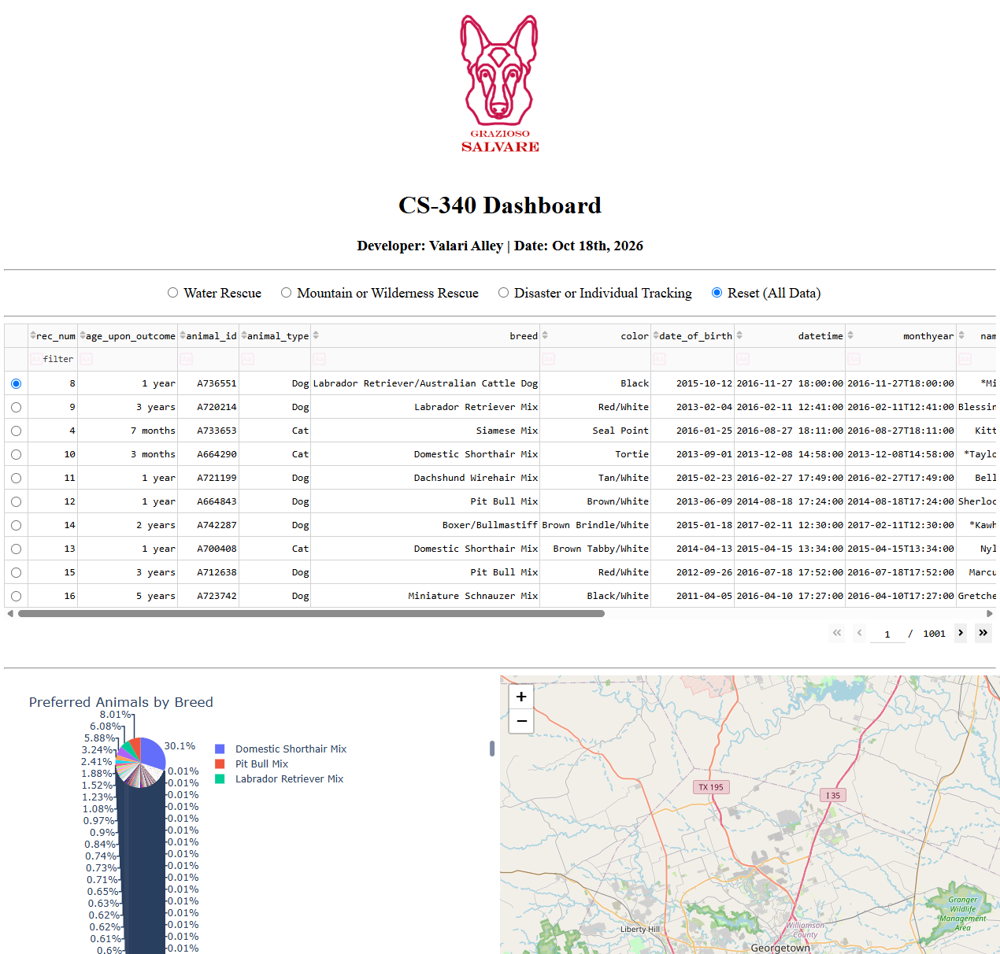
Water Rescue Filter Applied:
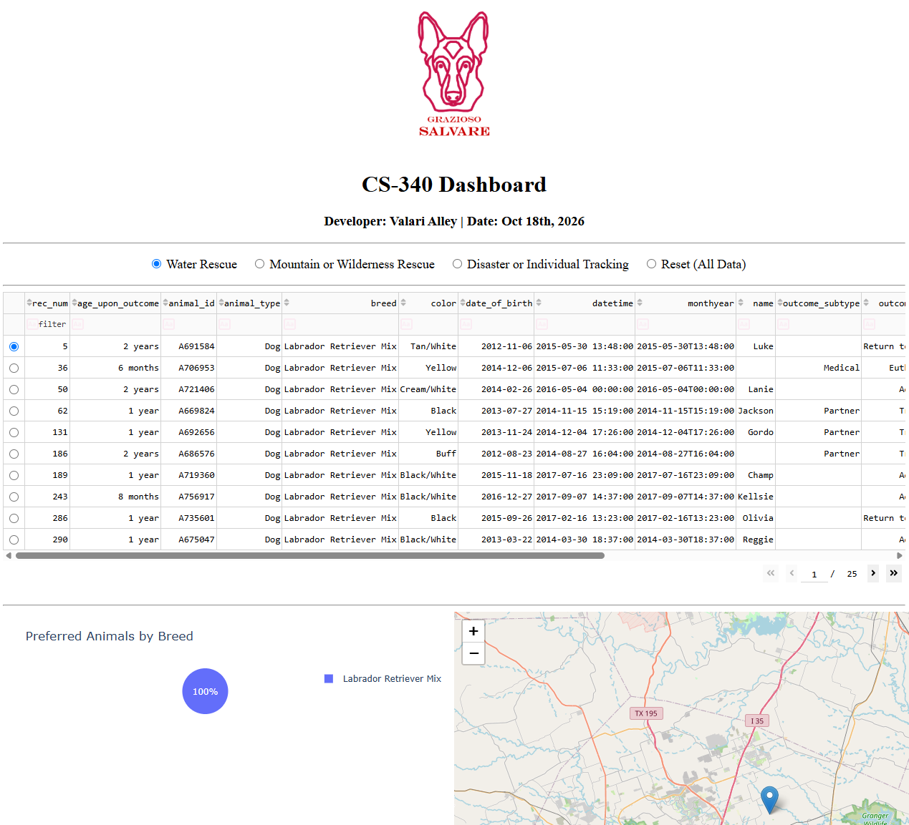
Mountain/Wilderness Rescue Filter Applied:
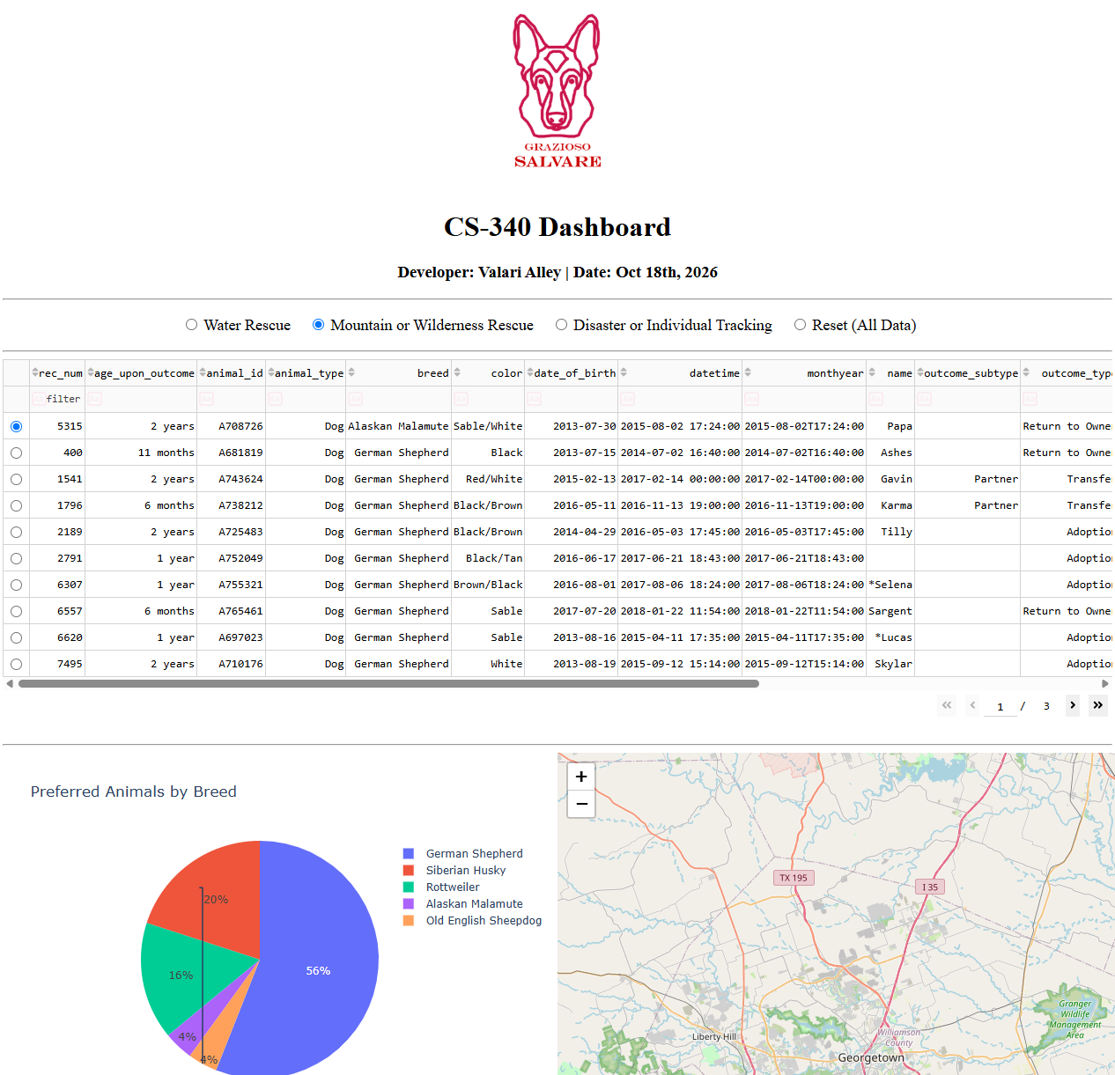
Disaster/Individual Tracking Filter Applied:
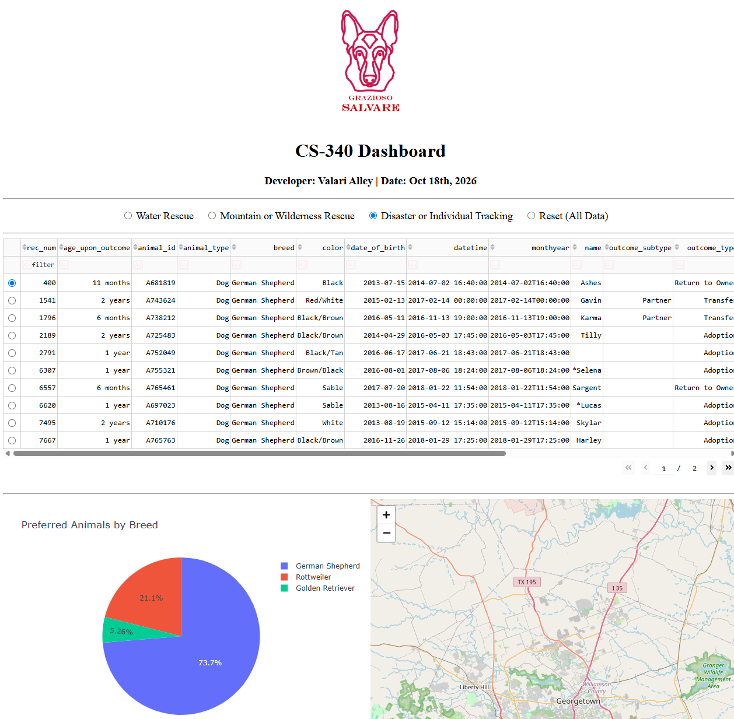

Tools Used and Rationale
- Python: Used as the primary backend language due to its extensive data manipulation libraries and seamless integration with both NoSQL databases and web frameworks.
- MongoDB (Model Component): A NoSQL, document-oriented database.
  - Rationale: MongoDB was chosen because animal shelter records often contain unstructured or semi-structured data. Its use of JSON-like BSON documents maps perfectly to Python dictionaries, making it incredibly efficient to query and manipulate large datasets in Python via the pymongo library without the rigid schemas of relational databases.
- Dash Framework (View & Controller Component): A Python framework for building analytical web applications.
  - Rationale: Dash effectively implements the MVC design pattern entirely within Python. The layout elements (html and dcc components) act as the View, rendering the interactive user interface. The @app.callback decorators act as the Controller, listening for user inputs (like clicking a radio button) and automatically updating the View widgets without requiring separate JavaScript, HTML, or CSS coding.
- Pandas: Used to transition the data retrieved from MongoDB into highly structured, easily manipulatable DataFrames before feeding it to the UI components.

Steps Taken to Complete the Project
- Database Connection (CRUD Module): Imported the custom Python CRUD module developed in Project One to securely connect to the MongoDB instance using the aacuser credentials.
- Initial Dashboard Layout: Constructed the baseline UI using JupyterDash, adding the Grazioso Salvare logo, the developer identifier, and establishing the HTML structure for the widgets.
- Unfiltered Data Table: Queried the database with an empty search parameter ({}) to pull the entire Austin Animal Center dataset into a Pandas DataFrame and populate the Dash DataTable.
- Filter Logic Development: Built custom MongoDB query dictionaries matching Grazioso Salvare's specifications for specific rescue types (e.g., combining $in operators for specific breeds and statuses, and $gte / $lte operators filter dogs between 26 and 156 weeks old).
- Controller Construction: Developed @app.callback functions linking the radio buttons to the data table, ensuring the table repopulated dynamically based on the queries defined in Step 4.
- Widget Integration: Added callbacks to link the Pie Chart and the Leaflet Map to the derived_virtual_data of the data table, ensuring the visuals always reflected the filtered data and user row selections.

Challenges Encountered and Overcome
Challenge: Handling the ObjectID format from MongoDB within the dash application.
- Description: When importing the raw query results directly into the Dash DataTable, the application would crash. This occurred because MongoDB assigns a unique _id field to every document of type ObjectID, which Dash and JSON cannot natively serialize or render in a frontend table.
- Solution: I utilized the Pandas .drop() method to identify and strip the _id column from the DataFrame (df.drop(columns=['_id'], inplace=True)) immediately after retrieving the data from MongoDB and before passing it to the Dash layout.

